**Homework 1 보고서**

**이름: 진방달**

**학번: 2016-23145**

**컴퓨터공학부**

**제출일자: 20170424**

|  |  |
| --- | --- |
| **Y** | **Part1:** Create a simple scene with animation. [20pt] |
| **Y** | **Part2:** Render the scene into a texture (texture01: color image) using FBO. |
| **Y** | **Part3:** Render the depth of the scene into another texture (texture02: grey image) using FBO. |
| **Y** | **Part4:** Create another scene with a rotating cube. Attach textures that you’ve created above on the faces of the cube. |

**Instructions:**

Use space bar to change mode 1-3

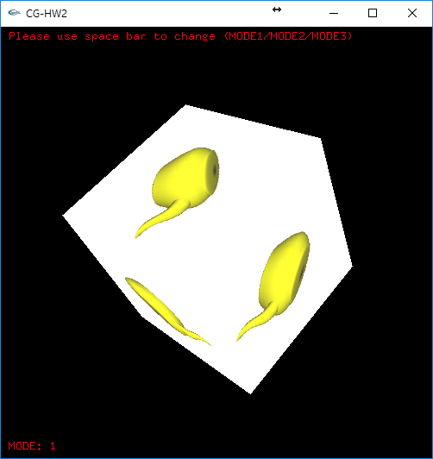

**<Mode1 – Color teapot>**

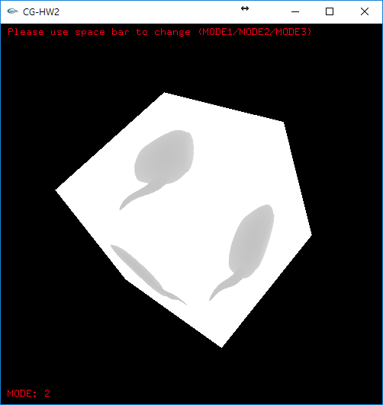

**<Mode2 – grey teapot>**

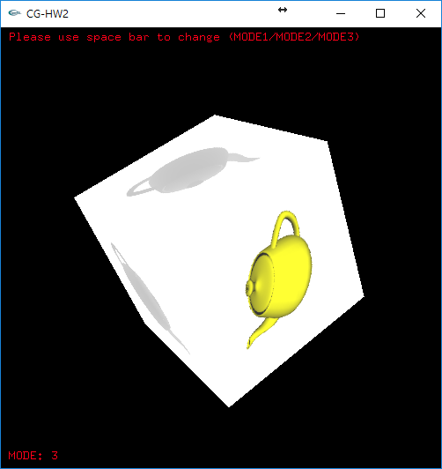

**<Mode3 – color teapot + grey teapot>**